**Sexual Intercourse – Notes**

* For sexual intercourse to take place, and for sperm to be deposited in the vagina, the penis must become enlarged and firm, a condition referred to as an erection.
* An erection results from blood rushing into spaces of the erectile tissue of the penis which is initiated by sexual excitation.
* When sexual stimulation of the penis within the vagina becomes sufficiently intense, rhythmic contractions of the epididymis, the vasa deferentia, the seminal vesicles and the prostate gland occur.
* These contractions propel the contents of the ducts and glands into the urethra and then out of the body – this process is called ejaculation.
* The ejaculated material consists of fluid (semen) which contains sperm.
* Accompanying ejaculation is a rapid heartbeat, an increase in blood pressure and breathing rate, and intensely pleasurable sensations; these reactions constitute an orgasm.
* Besides nourishment, semen provides the sperm with a fluid in which to swim and it also neutralises the acidic nature of the male urethra and female vagina; it also contains enzymes that activate the sperm once ejaculation has taken place.
* When the female is sexually stimulated, erectile tissue in the region of the vaginal opening fills with blood; this reduces the size of the vaginal opening and tends to increase the simulation of the penis during sexual intercourse.
* Arousal also results in copious secretions of mucus by glands located around the cervix and in the region of the vaginal opening; these secretions lubricate the epithelial lining of the vagina, allowing for easy entry of the penis.
* As sexual intercourse progresses, the external genitalia are rhythmically stimulated and, when sexual arouses reaches sufficient intensity, the female undergoes an orgasm, or climax.
* In a female orgasm, there many be an increase in the secretion of cervical mucus. A female doesn’t need to reach an orgasm for fertilisation to occur and it’s unknown whether female orgasm helps fertilisation.

**Fertilisation – Notes**

* Fertilisation – Secondary oocyte is joined to a sperm nucleus to form a **diploid nucleus**.
* Secondary oocyte is only able to be fertilised for **one day after ovulation**.
* Sperm remain viable for **1-3 days**.
* Fertilisation can only occur if **sperm is deposited into the female reproductive system (insemination)** no earlier than 3 days prior to ovulation and no later than one day after ovulation (**4-day window**).

Fertilisation steps:

1. The many sperm **break down the corona radiata**.
2. Sperm break through the corona radiata and **bind to zona pellucida**.
3. Sperm heads release **enzymes** which **tunnel through the zona pellucida** (acrosome reaction).
4. The first sperm through and binding to the secondary oocyte **loses its flagellum** and is **drawn into the oocyte cytoplasm**.
5. Secondary oocyte **completes Meiosis II**.
6. Each nucleus of the oocyte and sperm head **swell** (pronuclei), **rupture** and **both sets of chromosomes come together** to form **one nucleus** – a **diploid zygote**.

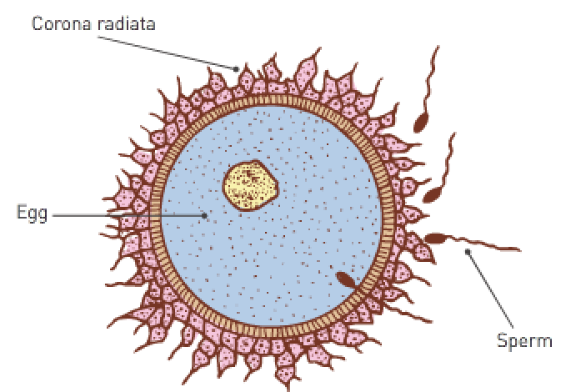

From zygote to blastocyst:

* The zygote takes **3-4 days to travel to the endometrium** in the uterus.
* The zygote undergoes **cleavage** (many mitotic divisions) to create more cells for the formation of a **morula**.
* A **blastocyst** is formed around **4 days after conception**.

The blastocyst consists of:

* An **inner cell mass** which later becomes embryo structures.
* A **hollow fluid-filled cavity** (called **blastocoel**).
* An **outer layer of cells (trophoblast)** which **surrounds the fluid-filled cavity** and **allows the blastocyst to burrow into the endometrium (implantation)**. These cells grow into **chorionic villi** which then form the **placenta**.
* Implantation occurs **7 days after ovulation** and allows the blastocyst to **gain nourishment** for growth and development by **absorbing nutrients from the glands and blood vessels of the uterine lining**.
* Implantation: The process of the **blastocyst moving from the cavity of the uterus** and **sinking into the endometrium** to become firmly attached to the wall of the uterus.

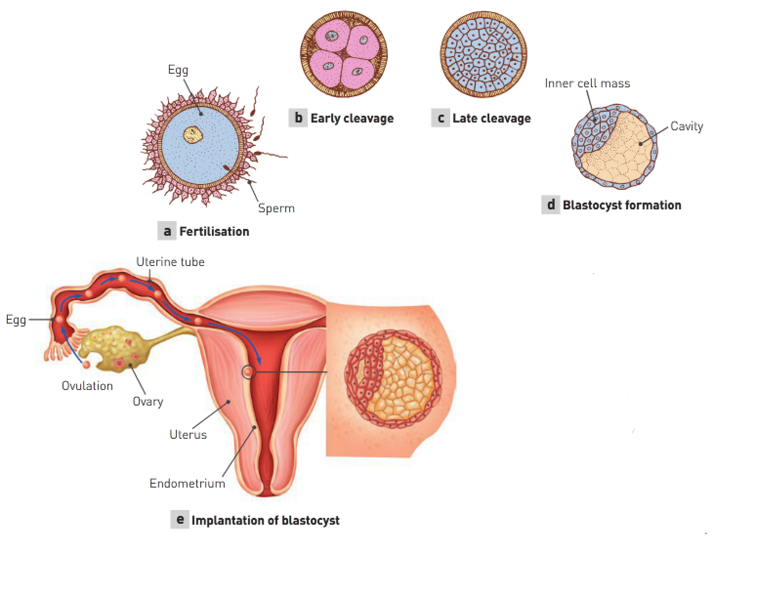

Hormonal maintenance of endometrium:

* The corpus luteum releases progesterone and oestrogen to **maintain the endometrium** until the placenta develops.
* Without blastocyst implantation, the corpus luteum would break down and FSH would be released by the pituitary to start the ovarian cycle.
* The **trophoblast** of the blastocyst has **become the chorionic villi**. Chorionic villi secrete HCG which **maintains the corpus luteum**.
* Note: Healthy embryo = health corpus luteum = healthy endometrium = sufficient nutrients for embryo.

Endometrium maintenance:

* The maintained corpus luteum (with high levels of hormones) **keeps the endometrium lining from being shed** and so the **menstrual cycle ceases**.
* The placenta takes 3 months to develop from finger-like projections of the chorionic villi. Once developed, it **maintains the endometrium** by **releasing oestrogens and progesterone**.

Primary germ layers:

* While the blastocyst is implanting in the endometrium, the inner cell mass undergoes changes resulting in the **primary germ layers**: the **endoderm** (inside), **mesoderm** (middle) and **ectoderm** (outside).
* These layers are the embryonic tissues that will **differentiate** into **all the tissues and organs of the body**.

|  |  |  |
| --- | --- | --- |
| **Endoderm**: | **Mesoderm**: | **Ectoderm**: |
| Lining of the alimentary canal and glands. | Skeletal, cardiac and smooth muscle. | Skin. |
| Lining of the respiratory system. | Cartilage, blood and bone | Hair, nails and sweat glands. |
| Lining of most internal organs. | Lymphatic tissue. | Nervous system. |

|  |  |  |
| --- | --- | --- |
| **Endoderm**: | **Mesoderm**: | **Ectoderm**: |
| Epithelium of alimentary canal and its glands. | Skeletal, smooth and cardiac muscles. | Epidermis of skin. |
| Epithelium of urinary bladder, urethra and gall bladder. | Cartilage, bone, blood and other connective tissue. | Hair, nails, glands of skin. |
| Epithelium of pharynx, auditory canal, larynx, trachea, bronchi and lungs. | Lymphoid tissue. | Lens, cornea and muscles of the eye. |
| Epithelium of tonsils, thyroid, parathyroid and thymus glands. | Endothelium of blood vessels and lymphatics. | Receptor cells of the sense organs. |
| Epithelium of vagina and associated glands. | Epithelium of body cavity and joint cavities. | Epithelium of mouth, nostrils, sinuses, glands of the mouth and anal canal. |
|  | Epithelium of kidneys and ureters. | Enamel of the teeth. |
|  | Epithelium of ovaries, testes and reproductive tracts. | Nervous system. |
|  | Epithelium of adrenal cortex. | Anterior lobe of the pituitary gland. |
|  | Dermis of skin. | Adrenal medulla. |

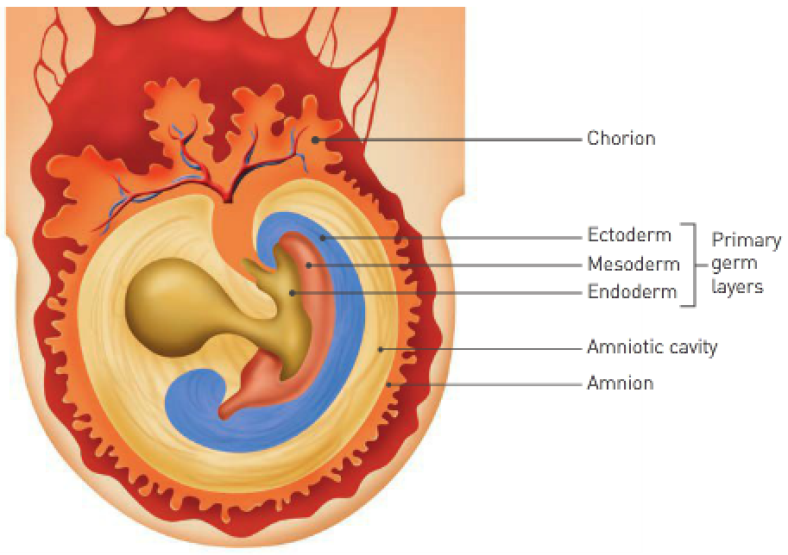

Embryonic membranes:

* Early in the embryonic period, 4 embryonic membranes form which serve to **protect and nourish the embryo** as it develops.
* Amnion: The **first** membrane to develop which **encloses the embryo in a cavity** into which it **secretes amniotic fluid**.
* Amniotic fluid serves to protect the embryo against physical injury by **acting as a shock absorber**; it also helps **maintain a constant temperature** and **allows the embryo to move freely**.
* Chorion: The **fourth** membrane to develop which **surrounds the embryo and the other 3 embryonic membranes**.
* As the amnion enlarges, it **fuses with the inner layer of the chorion**; eventually it becomes the main part of the foetal portion of the placenta.

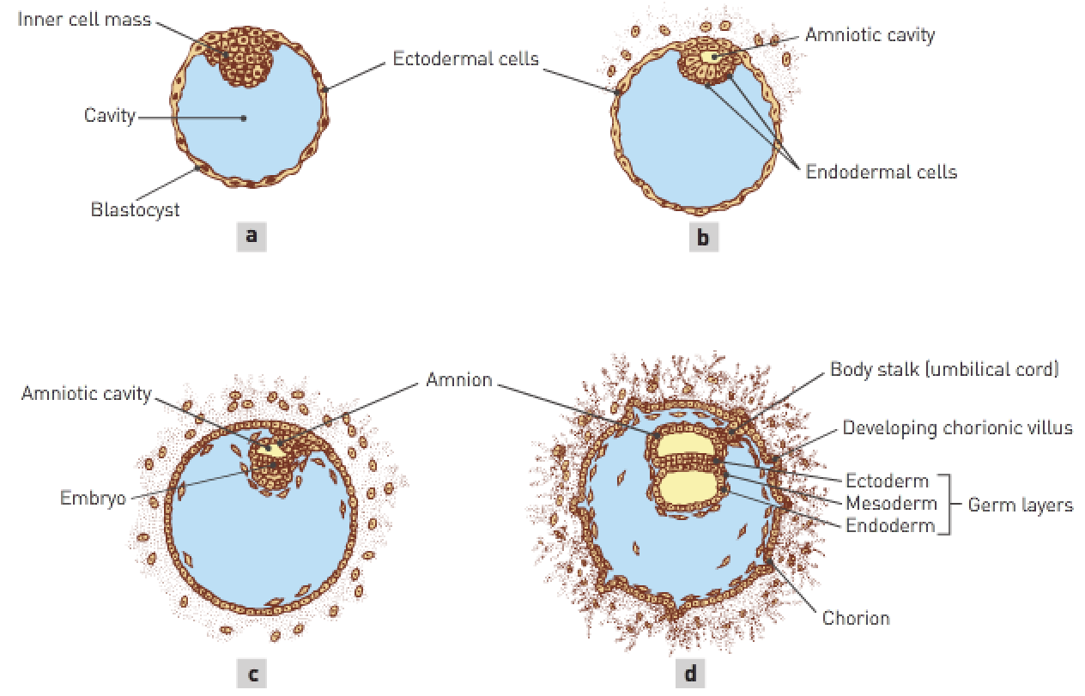

Placenta development:

* Placenta: An organ that **supplies nutrients to**, and **removes wastes from**, the **foetus**.
* It’s a combination of foetal and maternal tissues; the **foetal proportion** of the placenta develops from **part of the chorion** – an embryonic membrane formed from the **outer cells of the blastocyst** together with a **layer of mesodermal cells**.
* Chorionic villi are small finger-like projections that **burrow into the endometrium**.
* As they burrow further into the endometrium, the chorionic villi become **surrounded by the mother’s blood**. This **increases the surface area for exchange of substances** (O2, CO2, glucose, etc).
* Mother’s (maternal) and foetal (foetus after 2 months) blood **never mix**. Substances move across the cell layer by **diffusion or active transport**.

Placenta functions:

* Endocrine organ that **releases HCG** (from **chorionic villi**) to **maintain the corpus luteum initially**.
* Fully formed, it **releases its own oestrogens and progesterone** to **maintain the endometrium**.
* Provides a passage for nitrogenous wastes (urea, ammonia, uric acid, etc) to pass into the maternal blood so that the **mother’s kidneys can excrete**.
* Transports antibodies from the mother to provide **immunity**.
* Transports glucose, fatty acids, amino acids, minerals and vitamins **to the foetus** from the mother.
* Transports **oxygen into the foetal blood supply** and **CO2 into the mother’s blood supply**.
* Note: Foetal lungs aren’t functioning.

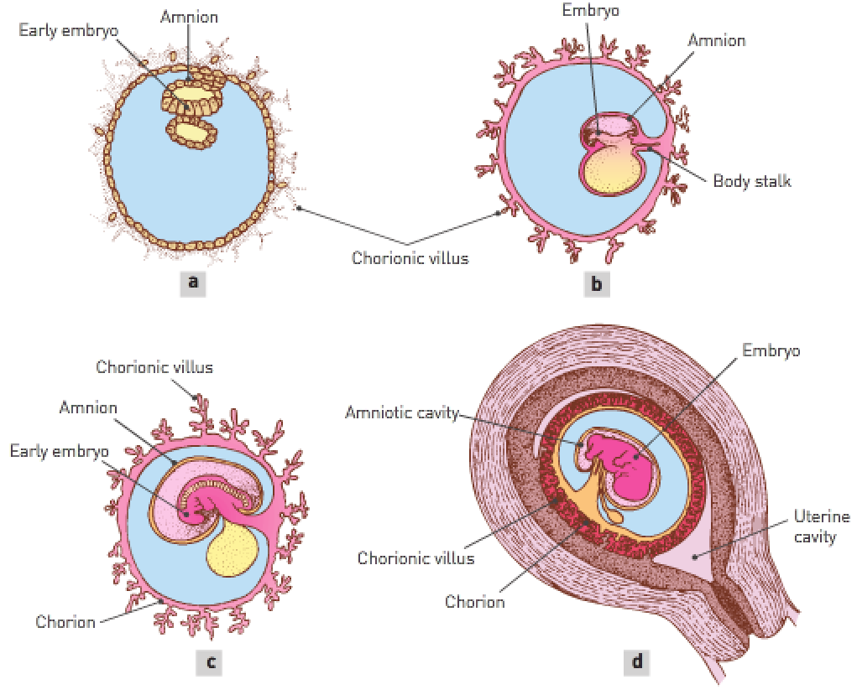

|  |  |
| --- | --- |
| **Role**: | **Function**: |
| Endocrine | Secretes a number of **hormones** necessary for maintaining pregnancy. |
| Excretory | Transports **nitrogenous wastes** e.g., urea, uric acid, ammonia and creatinine from the foetal blood **to the mother’s blood supply** for **excretion by the mother’s kidneys**. |
| Immune | Transports antibodies from the mother into the foetal blood supply so the foetus has **immunity** to some infectious diseases. |
| Nutritional | Transports **nutrients** e.g., glucose, amino acids, fatty acids, vitamins and minerals from the mother’s blood **to the foetal blood**; stores some essential nutrients early in pregnancy and releases them later when the demand is greater. |
| Respiratory | Transports **oxygen** from the mother **to the foetus**, and **carbon dioxide** from the foetus **to the mother**. |

Placenta blood supply:

* Placenta is **attached to the foetus** by the **umbilical cord**.

The umbilical cord has 2 umbilical **arteries** that **carry blood away from the foetus** (**deoxygenated waste-filled blood** carried **away from the foetal chorionic villi**).

One umbilical **vein** takes blood **near chorionic villi** (**oxygenated nutrient-filled blood** carried **towards the foetal chorionic villi**).

* When the male ejaculates, the sperm are released in the vagina at the entrance to the uterus, a process called insemination.
* Once within the vagina, the sperm travel through the cervix and the body of the uterus into the uterine tubes.
* They reach the upper portions of the uterine tubes quickly.

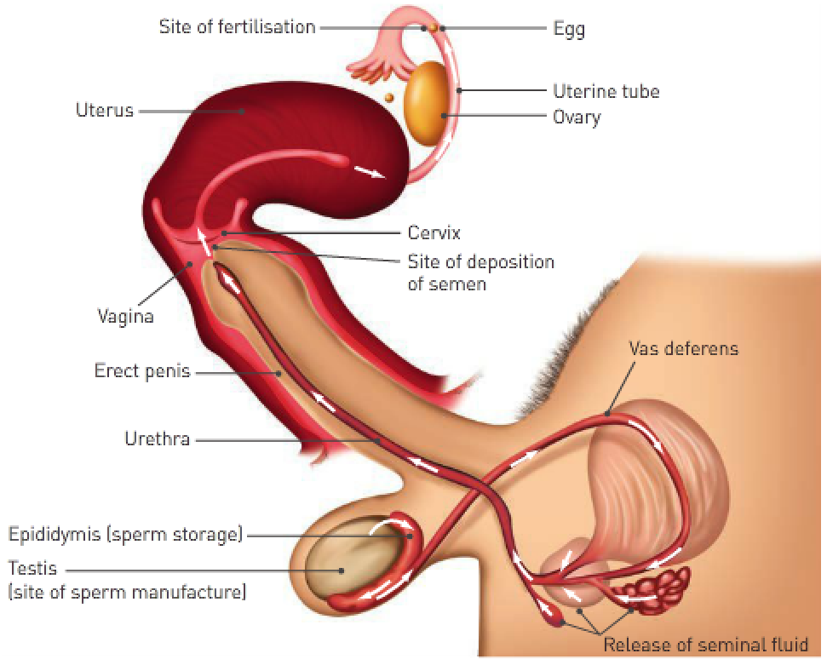

* Only a few thousand sperm reach the uterine tubes and sperm mortality is high.
* Fertilisation usually occurs in the uterine tubes when the egg is about one third of the way down the tube.
* Since ovulation, muscular contractions of the uterine tube, together with the beating action of cilia, have been transporting the egg towards the uterus.
* The mature egg is surrounded by a layer of follicle cells known as the corona radiata; an acid holds these cells together.
* The tips of sperm contain an enzyme capable of breaking own the acid that’s holding the cells of the corona radiata together; when several thousand sperm surround the egg, there’s enough enzyme to loosen the cells of the corona.



* The entrance of one sperm into the egg stimulates the formation of a fertilisation membrane around the egg, preventing the entrance of any more sperm.
* Once the sperm has entered the egg, the tail is absorbed, and the head begins to move through the cytoplasm of the egg in the form of a male pronucleus.
* The entrance of the sperm stimulates the egg (secondary follicle) to complete Meiosis II.
* The nucleus of the egg develops into a female pronucleus which fuses with the male pronucleus to form a single nucleus that now has the diploid number of chromosomes.
* Fertilisation is complete and the fertilised egg is called a zygote.